Asymmetric DCC correlation: GBPUSD and USDJPY
Method 10 / GARCH(1,1) + Cappiello-Engle-Sheppard ADCC / Alpari D1 full available history

Study setup
Logical pair: GBPUSD , USDJPY
Broker symbols: GBPUSD_i , USDJPY_i
Snapshot: 2026-11-03_majors_alpari_D1
Timeframe: D1
Matched return window: 1999-01-05 to 2026-11-02 (UTC bar dates)
Matched return count n: 7200
Dropped unfinished last bar dated 2026-11-03 UTC after a tick-volume check against the prior complete day.
GBPUSD GARCH(1,1): mu=0.000021, omega=0.004027, alpha=0.055334, beta=0.932275
USDJPY GARCH(1,1): mu=0.000110, omega=0.005012, alpha=0.051983, beta=0.935331
ADCC: a=0.029079, b=0.952576, g=0.016831, a+b+g/2=0.990071
Nested DCC (g=0): a=0.026275, b=0.966438
Negative shock: n = min(z, 0) in broker quote direction (not inverted)
Burn-in ignored in path summaries and chart: first 60 updates
Complete matched rows (Excel): GBPUSD-USDJPY_ADCC_D1.xlsx
Complete matched rows (HTML table): GBPUSD-USDJPY_ADCC_D1_data.html

Method carried forward
Asymmetric DCC extends Engle DCC with an extra term on joint negative standardised shocks. Each matched daily log return of close, ln(close_t / close_t-1), is first filtered by a constant-mean GARCH(1,1). Then z = residual / sigma and n = min(z, 0). The Cappiello-Engle-Sheppard recursion uses A = (1-a-b) Q_bar - g N_bar with N_bar = mean(n n'). Quotes are not inverted, so a negative shock is a negative log return in the broker quote. Nested symmetric DCC (g = 0) is fit on the same z path for comparison. Constraints: a,b,g >= 0 and a + b + g/2 < 1. Path summaries ignore the first 60 updates. The headline is latest ADCC rho. Pearson r is a side check only. This is not a cause, lead, or trading signal.

Results
Latest ADCC rho: -0.421207
Latest nested DCC rho: -0.400230
Post-burn-in ADCC path (n=7140): mean=-0.281857, median=-0.303554, min=-0.640001, max=0.586316, std=0.194587
Share of post-burn-in days with |rho| >= 0.4: 30.15%; |rho| >= 0.7: 0.00%
Same-sample Pearson r: -0.198556
ADCC minus r: -0.222651
ADCC minus nested DCC: -0.020977

Conclusion
Over 7200 matched daily log-return rows for GBPUSD and USDJPY (broker quote directions unchanged), latest ADCC rho is -0.4212 (negative, moderate conditional linear link in this sample) with fitted a=0.0291, b=0.9526, g=0.0168. Nested symmetric DCC latest rho is -0.4002 (ADCC minus DCC = -0.0210). After a 60-day burn-in, path mean is -0.2819 and std is 0.1946. Same-sample Pearson r is -0.1986 (ADCC minus r = -0.2227). This does not establish cause, lead-lag, or a lasting trading rule.

Charts
Daily closes

Daily log returns
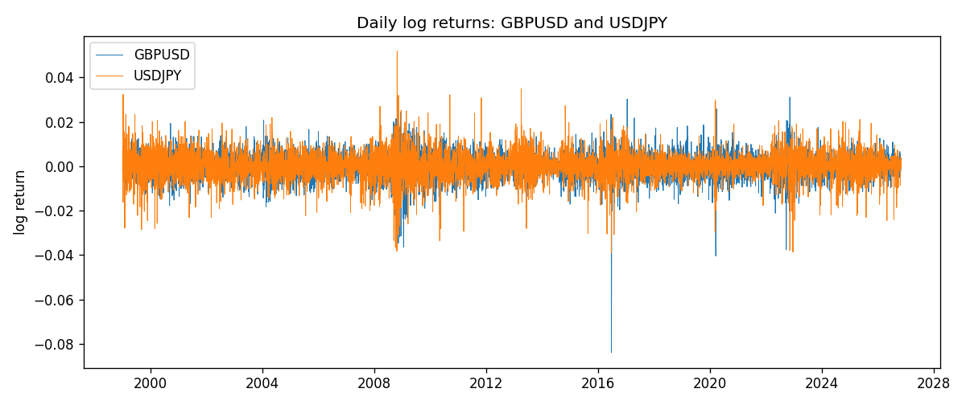
ADCC rho path with nested DCC and Pearson r
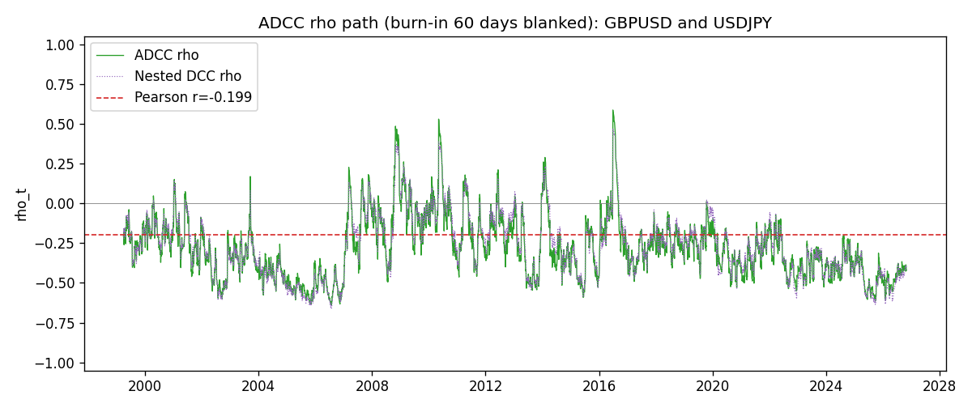

Data report
Every matched row that entered the ADCC recursion is stored in the sibling Excel workbook named GBPUSD-USDJPY_ADCC_D1.xlsx. Embedding all rows as a Word table is impractical at this length; the Word file holds the column list, column summaries, and the first and last 15 matched rows.
Columns: time, GBPUSD_open, USDJPY_open, GBPUSD_high, USDJPY_high, GBPUSD_low, USDJPY_low, GBPUSD_close, USDJPY_close, GBPUSD_tick_volume, USDJPY_tick_volume, GBPUSD_spread, USDJPY_spread, GBPUSD_real_volume, USDJPY_real_volume, GBPUSD_log_return, USDJPY_log_return, GBPUSD_sigma, USDJPY_sigma, GBPUSD_z, USDJPY_z, GBPUSD_n, USDJPY_n, q11, q22, q12, rho_adcc, rho_dcc
Column summaries (matched calculation rows)
column | count | mean | std | min | 25% | 50% | 75% | max
GBPUSD_open | 7200 | 1.5159933 | 0.21821503 | 1.06854 | 1.3249725 | 1.51133 | 1.63163 | 2.1066
USDJPY_open | 7200 | 113.81122 | 19.205564 | 75.693 | 104.42925 | 110.991 | 120.69125 | 163.824
GBPUSD_high | 7200 | 1.5222906 | 0.21878569 | 1.08366 | 1.329785 | 1.518035 | 1.638315 | 2.1161
USDJPY_high | 7200 | 114.30876 | 19.267108 | 76.001 | 104.8815 | 111.4435 | 121.26 | 163.978
GBPUSD_low | 7200 | 1.5096683 | 0.2174426 | 1.03518 | 1.319445 | 1.50319 | 1.6243 | 2.0983
USDJPY_low | 7200 | 113.28793 | 19.133561 | 75.402 | 103.89 | 110.5305 | 120.17 | 163.628
GBPUSD_close | 7200 | 1.5160611 | 0.21817876 | 1.06879 | 1.3250775 | 1.511235 | 1.63193 | 2.1065
USDJPY_close | 7200 | 113.82409 | 19.220954 | 75.811 | 104.42 | 111.028 | 120.6855 | 163.851
GBPUSD_tick_volume | 7200 | 94838.03 | 153554.65 | 62 | 10001.75 | 52905.5 | 91812.25 | 1273370
USDJPY_tick_volume | 7200 | 106136.9 | 179308.31 | 149 | 9925 | 53095 | 92761 | 1803508
GBPUSD_spread | 7200 | 26.967917 | 19.192953 | 0 | 11 | 20 | 50 | 50
USDJPY_spread | 7200 | 20.325556 | 17.633971 | 0 | 6 | 11 | 30 | 50
GBPUSD_real_volume | 7200 | 3.5565837e+09 | 8.4444068e+10 | 0 | 0 | 0 | 0 | 2.4038164e+12
USDJPY_real_volume | 7200 | 3.470121e+10 | 1.6077679e+11 | 0 | 0 | 0 | 0 | 3.8834203e+12
GBPUSD_log_return | 7200 | -2.396e-05 | 0.00564572 | -0.08388241 | -0.0031301 | 3.232e-05 | 0.00317911 | 0.03112653
USDJPY_log_return | 7200 | 4.769e-05 | 0.00620489 | -0.03908203 | -0.00320192 | 0.00011421 | 0.00340709 | 0.05184024
GBPUSD_sigma | 7200 | 0.00539738 | 0.00169183 | 0.00300578 | 0.00447948 | 0.00503976 | 0.00577871 | 0.02198508
USDJPY_sigma | 7200 | 0.005992 | 0.0017394 | 0.0033733 | 0.00477801 | 0.00569209 | 0.00679031 | 0.01882466
GBPUSD_z | 7200 | -0.00693688 | 1.0000213 | -10.312112 | -0.60076501 | 0.00254475 | 0.60692586 | 4.945389
USDJPY_z | 7200 | -0.00898837 | 1.0002803 | -6.5286361 | -0.5646688 | 0.00064387 | 0.58099606 | 7.1026381
GBPUSD_n | 7200 | -0.38643209 | 0.60994542 | -10.312112 | -0.60076501 | 0 | 0 | 0
USDJPY_n | 7200 | -0.37437751 | 0.62362436 | -6.5286361 | -0.5646688 | 0 | 0 | 0
q11 | 7200 | 1.0007544 | 0.29114272 | 0.50580441 | 0.85506656 | 0.96067404 | 1.0853084 | 6.2962322
q22 | 7200 | 1.0010937 | 0.29396537 | 0.48404774 | 0.80333921 | 0.94856379 | 1.1190115 | 2.7132581
q12 | 7200 | -0.26429271 | 0.22947455 | -0.97117706 | -0.40306882 | -0.27645742 | -0.15834091 | 2.2452689
rho_adcc | 7200 | -0.2807895 | 0.19427963 | -0.64000119 | -0.42124177 | -0.30169027 | -0.17229617 | 0.58631647
rho_dcc | 7200 | -0.27191411 | 0.19669878 | -0.65912072 | -0.42048802 | -0.28125297 | -0.15335647 | 0.4704685
First 15 matched rows (selected columns)
time | GBPUSD_log_return | USDJPY_log_return | GBPUSD_z | USDJPY_z | GBPUSD_n | USDJPY_n | q11 | q22 | q12 | rho_adcc | rho_dcc
1999-01-05 | -0.0028966287 | -0.00017868311 | -0.71537759 | -0.025708725 | -0.71537759 | -0.025708725 | 1 | 1 | -0.26441865 | -0.26441865 | -0.26441865
1999-01-06 | -0.00060452184 | 0.0075660159 | -0.15448333 | 0.6851883 | -0.15448333 | 0 | 0.98564196 | 0.96204767 | -0.25768655 | -0.26462682 | -0.26211643
1999-01-07 | -0.002118709 | -0.012851583 | -0.54005798 | -1.2131832 | -0.54005798 | -1.2131832 | 0.94956544 | 0.93951692 | -0.25519607 | -0.27018375 | -0.26325375
1999-01-08 | -0.0058954193 | -0.0047719894 | -1.5131891 | -0.45328046 | -1.5131891 | -0.45328046 | 0.92749434 | 0.97197324 | -0.21966608 | -0.2313557 | -0.2389939
1999-01-11 | -0.0056851331 | -0.016195423 | -1.400864 | -1.552983 | -1.400864 | -1.552983 | 0.99820131 | 0.94475247 | -0.18441117 | -0.18989746 | -0.21244909
1999-01-12 | 0.0022657001 | 0.032310364 | 0.53407629 | 2.9714713 | 0 | 0 | 1.0505278 | 1.0201131 | -0.08244009 | -0.079636198 | -0.14342065
1999-01-13 | 0.0091330396 | 0.0081373171 | 2.2000576 | 0.62637937 | 0 | 0 | 1.018573 | 1.2379334 | -0.039034344 | -0.034761793 | -0.090795774
1999-01-14 | 0.0019376331 | 0 | 0.4184113 | -0.0087631072 | 0 | -0.0087631072 | 1.1205887 | 1.2000762 | -0.0037622881 | -0.0032443263 | -0.054072059
1999-01-15 | -0.0017558204 | 0.0055343401 | -0.39550217 | 0.44620509 | -0.39550217 | 0 | 1.0821076 | 1.1526087 | -0.010342456 | -0.0092607785 | -0.055431338
1999-01-18 | 0.0012112405 | 8.7600193e-05 | 0.27040536 | -0.0018883767 | 0 | -0.0018883767 | 1.047542 | 1.1131783 | -0.021635659 | -0.020035586 | -0.060904584
1999-01-19 | 0.0018745281 | -0.0056219403 | 0.43038488 | -0.49948609 | 0 | -0.49948609 | 1.0095605 | 1.0698285 | -0.027276433 | -0.026246072 | -0.062271318
1999-01-20 | -0.0049053846 | -0.0053879917 | -1.1646187 | -0.49100178 | -1.1646187 | -0.49100178 | 0.9766404 | 1.0399882 | -0.038885993 | -0.038584391 | -0.0688536
1999-01-21 | 0.0031518998 | 0.0084664056 | 0.72949041 | 0.76492086 | 0 | 0 | 1.0021643 | 1.0111772 | -0.017441253 | -0.017325852 | -0.054108645
1999-01-22 | 0.0024781662 | 0.0060412564 | 0.5772895 | 0.55127803 | 0 | 0 | 0.97968311 | 0.98967863 | -0.0070399583 | -0.0071495743 | -0.040322944
1999-01-25 | 0.0012066366 | -0.0073594164 | 0.2824452 | -0.71023166 | 0 | -0.71023166 | 0.95248449 | 0.96102275 | -0.0041037719 | -0.0042893099 | -0.03319698
Last 15 matched rows (selected columns)
time | GBPUSD_log_return | USDJPY_log_return | GBPUSD_z | USDJPY_z | GBPUSD_n | USDJPY_n | q11 | q22 | q12 | rho_adcc | rho_dcc
2026-10-13 | 0.0036434319 | -0.0018932826 | 0.98661023 | -0.41109181 | 0 | -0.41109181 | 0.80962084 | 0.88892497 | -0.34147974 | -0.40252378 | -0.41647218
2026-10-14 | -0.0049164679 | 7.5800166e-05 | -1.3339188 | -0.0071361194 | -1.3339188 | -0.0071361194 | 0.80910172 | 0.86396848 | -0.34373152 | -0.41112022 | -0.41985386
2026-10-15 | 0.0065976411 | -0.0018524319 | 1.7258511 | -0.4189628 | 0 | -0.4189628 | 0.86199087 | 0.83243927 | -0.33364543 | -0.39387423 | -0.40584963
2026-10-16 | 0.0037592051 | -0.00037976126 | 0.92499223 | -0.10630672 | 0 | -0.10630672 | 0.91729621 | 0.8104615 | -0.34550074 | -0.40070797 | -0.40664941
2026-10-19 | -0.0017500314 | 0.0034946841 | -0.43716928 | 0.75006666 | -0.43716928 | 0 | 0.90824554 | 0.78198628 | -0.33862718 | -0.40180988 | -0.40305902
2026-10-20 | 0.0055923442 | -0.0022546642 | 1.3985997 | -0.52686594 | 0 | -0.52686594 | 0.88351795 | 0.77070246 | -0.33875535 | -0.41052074 | -0.40731256
2026-10-21 | 0.0012476328 | -0.00032883504 | 0.29832416 | -0.099033084 | 0 | -0.099033084 | 0.90806971 | 0.75633793 | -0.35076982 | -0.42325752 | -0.41487983
2026-10-22 | 0.00022396082 | -0.0085942669 | 0.050424854 | -2.0035452 | 0 | -2.0035452 | 0.87716427 | 0.73036089 | -0.34164608 | -0.42684207 | -0.41386485
2026-10-23 | -0.0021146949 | 0.00035080446 | -0.54132394 | 0.051239069 | -0.54132394 | 0 | 0.84521047 | 0.8894563 | -0.33503371 | -0.38640592 | -0.39064031
2026-10-26 | -0.0024340661 | 0.0041238746 | -0.63041787 | 0.87241366 | -0.63041787 | 0 | 0.82815112 | 0.85679237 | -0.32660369 | -0.38772919 | -0.38856887
2026-10-27 | -0.0023648393 | 0.0027651658 | -0.61859794 | 0.57751379 | -0.61859794 | 0 | 0.81669355 | 0.8477333 | -0.33375989 | -0.40112059 | -0.39768039
2026-10-28 | 0.0015771808 | -0.00095679538 | 0.40762203 | -0.234813 | 0 | -0.234813 | 0.80510155 | 0.82667017 | -0.33497214 | -0.41059837 | -0.40327997
2026-10-29 | 0.0035881935 | -0.00038043789 | 0.94904781 | -0.11003014 | 0 | -0.11003014 | 0.78132293 | 0.79943878 | -0.32852176 | -0.41567725 | -0.40365883
2026-10-30 | 0.0013450605 | -0.0010596481 | 0.35046824 | -0.26766779 | 0 | -0.26766779 | 0.78003154 | 0.77152328 | -0.32263054 | -0.41588655 | -0.39965602
2026-11-02 | 0.0010971256 | 0.0026438521 | 0.28963831 | 0.59021334 | 0 | 0 | 0.75618191 | 0.74766509 | -0.31671003 | -0.42120656 | -0.40023003

